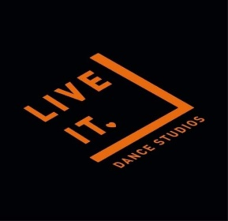
Medical Form
2020-2021
GUIDANCE: To complete, just click each field in the grey box and start typing or use the tab key to move to the next field. You do not have to physically sign this form, just type in your name in the signature field.
Students Name:
Date of Birth:
Age:
Home address: | Line 1:  Line 2:  Line 3:  Postcode:
Parent/Carers Phone number:
Parent/Carers Email:
Emergency Contact
Name:
Relationship:
Phone number:
Emergency Information
Doctors name:
Doctors address: | Line 1:  Line 2:  Line 3:  Postcode:
Allergies (food, medicine, etc):
Medical conditions:
Declaration
I agree that for the 2020 – 2021 year that all the information applied is correct and in the absence of myself that the ’Live It’ staff can take full responsibility for my child’s medical conditions. I agree that in the event of my child or any of my family showing symptoms of the COVID virus I will follow Government Guideline and stay at home. I will also inform Live It Dance Studios immediately. Children may be photographed and videoed for ‘Live It Dance Studios’ promotional purposes throughout. If you object to this, please let us know in writing. I agree that all my information will be held by ‘Live It Dance Studios LTD’ and passed to the NHS, exam boards and schools for necessary use.
Parent/Carer Signature:
Date:

